Online Resume Creator

22nd Annual Information Technology Competition (ITC)

Alyssa Benipayo

Erickson Angeles

Eric Kha

Ryan Trenh

Maria Vargas

Table of Contents

**Introduction**2

**Specific Developer Build Softwares**2

Eclipse IDE 2

Web Design Applications 2

Java 2

Java Server and JRE Library 2

Github 3

**Build Performance**3

Current Online Resume Creator Architecture 3

Future Online Resume Creator Architecture 6

**Authors**6

**Faculty Advisor**6

# Introduction

The purpose of this project is to develop an Online Resume Creator that can automatically help users create professional resumes. The users only need to pick one of out the four resume templates and fill in the corresponding sections. To save the resume, the Online Resume Creator provides the options to either download the resume or email it.

Our submitted project is a prototype, but we will complete our official Online Resume Creator by April 14th.

# Specific Developer Build Softwares

## Eclipse IDE

We used the Eclipse IDE to build our Online Resume Creator. Eclipse is a community for individuals and organizations who wish to collaborate on commercially-friendly open source software. Its projects are focused on building an open development platform comprised of extensible frameworks, tools and runtimes for building, deploying and managing software across the lifecycle. For a full description of the the software, visit the official home page: <http://www.eclipse.org>

## Web Design Applications

Regarding the presentation of our web pages, we utilized HTML, CSS, and Bootstrap (for themes).

For full tutorials, click on the the following links:

* HTML: <https://www.w3schools.com/html/>
* CSS: <https://www.w3schools.com/css/>
* Bootstrap: <https://themes.getbootstrap.com/>

## Java

The programming language is Java. The following link is the tutorial to learn the language:

<https://www.tutorialspoint.com/java/index.htm>

## Java Server and JRE Library

To deploy and run our JSP and Java Servlet, we used Apache Tomcat., which is an open source implementation of the Java Servlet, JavaServer Pages, Java Expression Language and Java WebSocket technologies. For more information, visit Apache Tomcat’s website: <http://tomcat.apache.org/> We also utilized the Java SE Runtime Environment (JRE) library to run Java language. Downloads for the JRE Library is available at <http://www.oracle.com/technetwork/java/javase/downloads/jre8-downloads-2133155.html>.

## Github

We added our working code on a development platform called Github. Github is a platform where we can host and review code, manage projects, and build software alongside millions of other developers. For more details, visit <https://github.com>.

# Build Performance

## Current Online Resume Creator Architecture

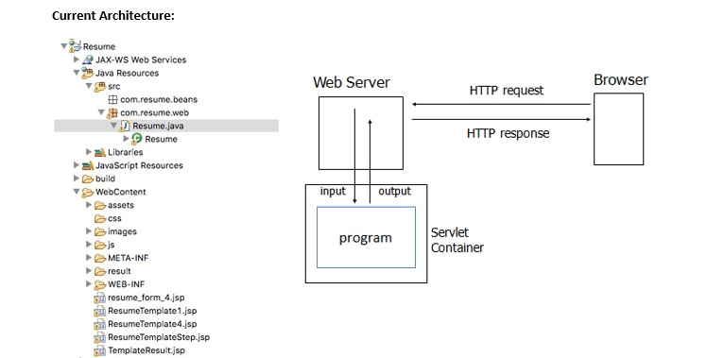

1. The request comes to Filter via web.xml. No validation at the moment.
2. User input information on Resume form.

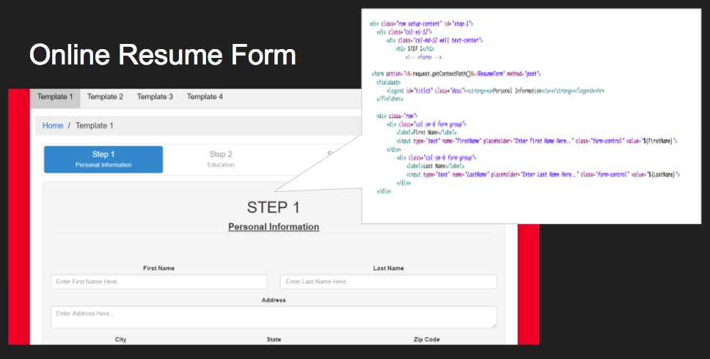

1. Servlet collects the information from the user input

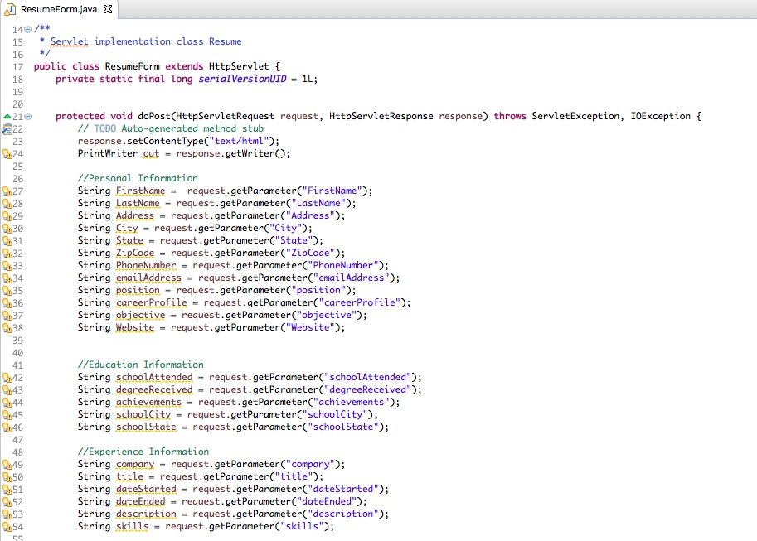

1. Result will be posted on a new jsp page.- to collect information from the servlet, we use the most basic scripting functions <% ... %>, which encloses a JSP scriplet. A scriptlet is a fragment of Java code that is run when the user requests the page.

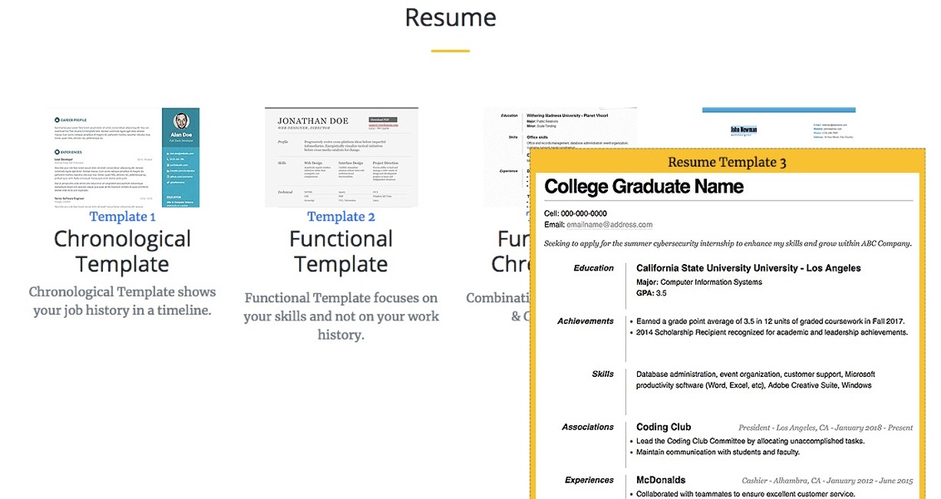

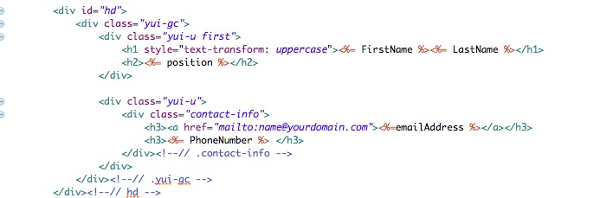

## Future Online Resume Creator Architecture

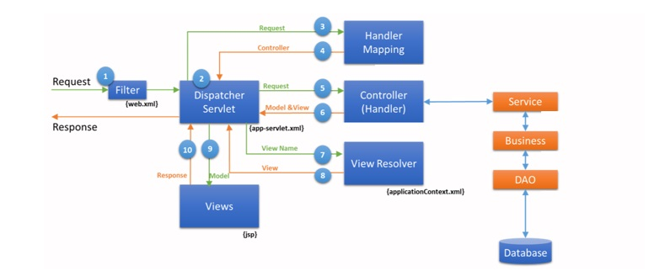

1. The request comes to Filter via web.xml. All pre-processing, security validations, sessions checks are completed and request is forwarded to DispatcherServlet defined in web.xml
2. It automatically loads the spring configuration file whose name format is <servlet-name>-servlet.xml,where <servlet-name> is configured in web.xml file.
3. The DispatchServlet consults Handler Mapping to decide controller class to delegate.
4. The Handler Mapping decides one controller among many controllers based on URL path.
5. The DispatchServlet delegates request to the corresponding Controller.
6. The Controller returns ModelAndView, which contains logical view and model data, back to DispatchServlet.
7. The DispatcherServlet consults a view resolver to resolve response view name including its location.
8. The ViewResolver returns physical response view page name.
9. Finally, the DispatchServlet does view navigation to response page.

# Authors

Alyssa Benipayo

Erickson Angeles

Eric Kha

Ryan Trenh

Maria Vargas

# Faculty Advisor

Shilpa Balan